**CCD Astrometric Measurements of WDS 08167+4053 using the iTelescope network**

Dewei Li1, Junyao Li1, Aren Dennis1, Bill Riley2, Grady Boyce3 and Pat Boyce3.

1. Army and Navy Academy, Carlsbad, California
2. Cuesta College
3. Boyce Research Initiatives and Education Foundation

**Abstract:** S*eparations and position angle astrometric measurements were made of the multiple star system WDS 08167+4053 AB, AC, and BC components. Our measurements were compared favorably with historical measurements from the United States Naval Observatory Washington Double Star Catalog.*

**Introduction**

Our study was conducted as part of a college seminar provided by Cuesta College supported, by the Institute for Student Astronomical Research (InStAR), and conducted by Boyce Research Initiatives and Education Foundation at the Army and Navy Academy (ANA). ANA is a college preparatory Middle and High School with a military structure focused on personal growth and leadership. Our team is shown if figure 1.

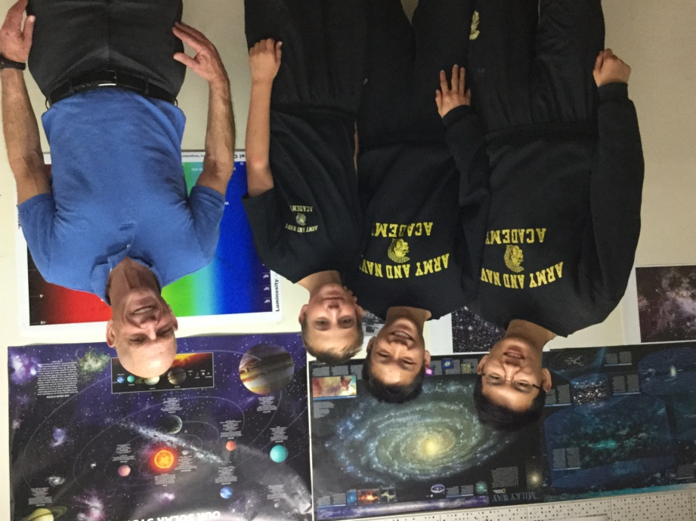

*Figure 1: Team Nail - Left to right: Dewei Li, Junyao Li, Aren Dennis, and Bill Riley.*

The selection criteria for this paper were binary stars having a maximum magnitude difference of four between the stars, angular separation greater than seven arc seconds, and lacking recent observations. Limiting the magnitude difference allowed the candidates to be clearly separated without stars of brighter magnitudes becoming overexposed during CCD imaging. Separations above seven arc-seconds ensure that the separate stars to be resolved on the CCD chip given the instruments used for this project.

WDS 08167+4053 matched the candidate criteria. This binary star system lacks recent measurements, has a separation greater than 7.0 arc-seconds, and component magnitudes of 9, 9.9 and 10.1 for A, B and C stars respectively. Additionally, this system contains more than three published observations allowing a comparison between the measurements of this paper against the historical values. Figure 2 shows WDS 08167+4053 in Mira Pro typical measurement of an AB pair of WDS 08167+4053.

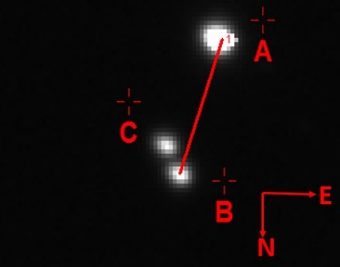

*Figure 2: WDS 08167+4053 with AB pair marked in Mira Pro x64.*

**Equipment and Procedures**

CCD measurements were completed using telescope T7 from the iTelescope network. T7 is a Planewave 17" CDK located in Nerpio, Spain at an elevation 5413 feet. Images were taken on two different nights, with luminance and Ha filters, and three different exposure times. Telescope T7 and CCD camera specifications are show in Figure 3.

|  |  |
| --- | --- |
| C:\Users\billrileyusc\Downloads\T07-scope.jpg | Optical Design: Corrected Dall-Kirkham Astrograph  Aperture: 431mm  Focal Length: 2929mm  F/Ratio: f/6.8  Mount: Paramount PME  Instrument Package  CCD: SBIG STL-11000M  Anti-Blooming Gate (ABG)  Resolution: 0.63 arc-secs/pixel  Array: 4008 by 2672 (10.7 Mega pixels)  FOV: 28.2 x 42.3 arc-mins |
| T7 Planewave 17" CDK | Observatory: Nerpio, Spain |

*Figure 3. ­iTelescope Platform used in the Boyce Astro Binary Star Research Seminar.*

Images were acquired at epochs 2015.775 and 2015.795 with exposures of 60, 120 and 240 seconds using Ha and luminance filters for a total of thirty-two images. Several of the images were discarded due to diffraction spikes and fused centroids ( see in Figure 4) that were producing significant variances in position angle and erroneous centroids throughout several attempts to obtain accurate data from those images.

|  |  |
| --- | --- |
|  |  |
| Diffraction spiking  Luminance filter  120 second exposure | BC pair fused  Luminance  120 second exposure |

*Figure 4. Typical examples of images with no measurement used.*

The remaining images were preprocessed (dark and flat subtraction) by iTelescope and then downloaded for analysis. MaximDL v6 was used to insert World Coordinate System (WCS) positions into the FITS headers through comparison of the image star field against the Fourth U.S. Naval Observatory CCD Astrograph Catalogue (UCAC4). During this process, MaximDL typically used approximately 180 stars out of a database of 790 stars for this particular star field.

Mirametrics Mira Pro x64 was used to locate accurate position angles and separations of the component stars. The A, B, and C stars were identified, marked, and then measured for position angle and separation through the algorithms of Mira Pro able of locating the centroid of each star. Each stellar centroid RA and Dec, calculated position angle, and angular separation between the stars were recorded and entered into Microsoft Excel to calculate the standard deviation and standard error of mean from the astrometric results.

**Results**

Table 1 shows the average of the measurements, the standard deviation, and the standard error of the mean for separation in arc seconds and position angles in degrees of the AB, AC, and BC pairs of WDS 08167+4053.

|  |  |  |  |  |
| --- | --- | --- | --- | --- |
| **WDS 08167+4053** | | | | |
| **Pair** | **Observations used** |  | **Position Angle**  **(degrees)** | **Separation**  **(arc seconds)** |
|  |  | Mean | 344.6 | 20.8 |
| **AB** | 19 | Standard Deviation | 0.36 | 0.02 |
|  |  | Std. Error of Mean | 0.083 | 0.005 |
|  | | | | |
|  |  | Mean | 333.8 | 17.8 |
| **AC** | 25 | Standard Deviation | 0.82 | 0.10 |
|  |  | Std. Error of Mean | 0.164 | 0.02 |
|  | | | | |
|  |  | Mean | 209.7 | 4.74 |
| **BC** | 19 | Standard Deviation | 0.32 | 0.03 |
|  |  | Std. Error of Mean | 0.073 | 0.069 |

*Table 1: Mira Pro measurement of the pairs of WDS 08167+4053.*

The comparison between these measurements and the published measurements in the WDS are found in Table 2.

|  |  |  |  |  |  |  |  |  |  |  |  |
| --- | --- | --- | --- | --- | --- | --- | --- | --- | --- | --- | --- |
| **WDS Number** | | **Pair** |  | **Observation Epoch** | | **Position Angle deg.** | | | **Separation arc-sec** | | |
|  | |  |  | **WDS Historical** | | **WDS Historical New** | | | **WDS Historical New** | | |
|  |  |  | # | **First** | **Last** | **First** | **Last** | **2015** | **First** | **Last** | **2015** |
| WDS |  | AB | 20 | 1957.19 | 2010.265 | 249.6 | 343.8 | 344.7 | 20.4 | 20.88 | 20.8 |
| 08167+4053 |  | AC | 12 | 1969.052 | 1998.28 | 327.12 | 331.1 | 333.8 | 17.912 | 17.98 | 17.8 |
|  |  | BC | 19 | 1894.31 | 1998.28 | 210 | 209.9 | 209.9 | 4.419 | 4.8 | 4.75 |

*Table 2. Comparison with WDS Catalog data*

**Discussion**

Several CCD images, and their respective measurements, were dropped due to the saturation and diffraction flaws described above. Fusing of stellar centroids in a CCD image occurs when adjacent stars are too close together on the CCD imaging chip allowing the light from each star to blend preventing an accurate location of each independent stellar centroid. Such a situation is common in stars with small separations. In imaging this binary star system, the BC pair had a separation of only 4 arc seconds. This resulted in the blending of the two star’s centroids, and thus inaccurate measurements.

Review of the WDS historical data raised questions surrounding the historical measurements of two observations (epoch 1957 and epoch 1983) with regard to the position angle. These points might require further investigation as they are several standard deviations from the mean. The mean for the data group is 341 degrees and the standard deviation is 2.11 degrees.

|  |  |  |  |
| --- | --- | --- | --- |
| **Epoch** | **Position Angle** | **Separation** | **Note** |
| 1957.19 | 249.6 | 20.4 | PA differs |
| 1969.051 | 338.64 | 20.454 |  |
| 1973.137 | 339.137 | 20.534 |  |
| 1974.047 | 339.198 | 20.474 |  |
| 1982.041 | 339.911 | 20.387 |  |
| 1982.937 | 339.733 | 20.378 |  |
| 1983.44 | 335.5 | 19.224 | PA differs |
| 1984.216 | 340.292 | 20.452 |  |
| 1987.14 | 340.403 | 20.382 |  |
| 1987.263 | 341.8 | 20.47 |  |
| 1987.263 | 341.3 | 20.54 |  |
| 1989.938 | 341.161 | 20.534 |  |

*Table 3. Historical data AB pair. The two position angles appear questionable*

Microsoft Excel was used to develop a scatter plot of the XY coordinate position of each pair. The results are shown in Figures 5, and 6. The current measurements from this activity are indicated by an amber hexagon. In Figure 6, note that the outliers are omitted, with the relative positions of the BC pair over time being tightly grouped.

*Figure 5. XY plot of AB pair historical position. Present data is shown with a hexagon. Squares indicate component C and diamonds indicate component B. Questionable point at Epoch 1957 removed.*

*Figure 6. XY plot of BC pair historical position. Present data is shown with a hexagon. If the outlier points at Epochs 1895, 1957 and 1980 are removed there is no apparent movement between B and C.*

**Conclusion**

Our observed data was consistent with that of the USNO WDS Catalog published measurements showing consistency and a continuation of the historical the trend. The current measurements do not support different proper motion of components B and C.

**Acknowledgements**

The authors thank the United States Naval Observatory for providing historical measurement data and iTelescope for the use of their service. Additionally, we thank the Boyce Research Initiatives and Education Foundation (B.R.I.E.F.) for their generous financial donation that allowed us to use the iTelescope robotic telescope system and their proprietary software. We thank Mirametrics for providing access to Mira Pro x64 for accurate astrometric measurements of our binary star system. The authors thank Russ Genet for providing guidance.

**Reference**

Frey, Thomas G. Johnson, Jolyon, Almich, Christopher J., and Genet, Russell M. 2010. Visual Double

Star Measurements with Equatorial and Alt-Azimuth Telescopes. Small Telescopes and Astronomical Research. Chapter 10, eds Russell M. Genet, Jolyon M. Johnson, and Vera Wallen. Collins Foundation Press.

Mason, B. and Hartkopf, W. The Washington Double Star Catalog, October 2015. Astrometry

Department,U.S. Naval Observatory. <http://ad.usno.navy.mil/wds/wds.html>. Department, U.S. Naval Observatory. <http://www.usno.navy.mil/USNO/astrometry/optical-IR-prod/ucac>.

Genet, R.M., Johnson, J.M., and Wallen, V. 2010. *Small Telescopes and Astronomical Research*.

Dr. Vera Wallen Chief Editor.